Chapter 10, Solution 9.

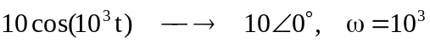
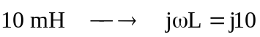
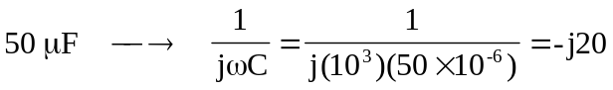

Consider the circuit shown below.
j10 W
20 W
-j20 W
20 W
10Ð0° V
+
-
4 I_{o}
V₁

V₂

+
V_{o}
-

30 W
I_{o}

At node 1,
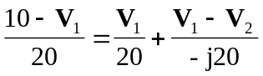
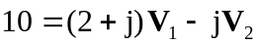 (1)

At node 2,
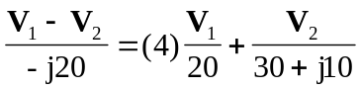, where 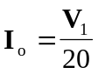 has been substituted.
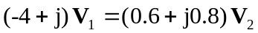
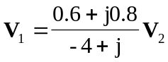 (2)

Substituting (2) into (1)
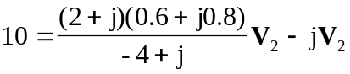
or 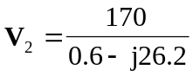

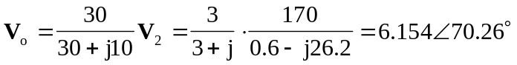
Therefore, 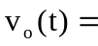 6.154 cos(10³ t + 70.26°) V

